ELEVATE YOUR LODGE'S IMPACT

A SOUP TO NUTS MARKETING TOOLKIT FOR MASONIC LODGES, SIMPLE ENOUGH FOR ANYONE AND EVERYONE (even ai)
This marketing toolkit (or “marketing package” as some would know it) empowers Masonic lodges to effectively communicate their values, traditions, and community involvement while complying with "no solicitation for membership" rules. We provide the tools to enhance their online presence through social media and content marketing, helping lodges connect with their communities, promote charity initiatives, and showcase their unique stories. This valuable resource is always offered for free, supporting lodges in preserving Masonic traditions and expanding their positive influence on society.
The below is written to support any Masonic Lodge, anywhere in the world. You can even use this marketing toolkit to train your own AI tool with your lodge’s information.
PS: Don’t fall for death by committee, sometimes you just need one or two passionate individuals to run with it!

FAQ BEFORE YOU START
- How do I get started with this marketing toolkit?
  - We offer a step-by-step guide for each element of the marketing strategy from checklists to content, helping you kickstart your marketing efforts with ease.
- Is this marketing toolkit suitable for beginners in marketing and social media?
  - Yes, we've designed this toolkit with beginners in mind. You don't need prior marketing knowledge to use it effectively.
- How can I adapt the content to suit my Masonic lodge's unique identity?
  - We provide customizable templates and content ideas to ensure you can tailor the toolkit to reflect your lodge's personality and values.
  - Simply replace words in brackets with your information! Example: [MY LODGE] = Blendon 339
- Do I need a budget for software or tools to implement these strategies?
  - No, we've kept things simple! You can create content and manage your social media using free/basic software and platforms.
- What are the key benefits of using this marketing toolkit for my Masonic lodge?
  - By using this toolkit, you can enhance your lodge's community presence, reach a wider audience, engage your members and community, and support local charitable causes more effectively because of it.
- Are there more free to use resources like this out there?
  - Yes! You’ll find a collection of dozens more free resources on freemasonmarketing.com. Resources produced by guys like you, me, local Masonic districts and even Grand Lodges!
  - Be sure to check out your own Grand Lodge and district for more resources!

CHECKLIST BEFORE YOU START
This toolkit assumes you have a website, social media accounts already established and your content is fresh. If that's not the case, please refer to this checklist. Otherwise skip ahead!

- Establish a Digital Presence:
  - Create a basic website for [MY LODGE].
  - Ensure the website includes key information: About Us, Contact, Events, and Charitable Work.
- Set Up Social Media Accounts:
  - Choose platforms and local interest social media groups popular in [MY CITY]
  - Keep usernames consistent across platforms for easy recognition.
- Google Business Profile:
  - Register [MY LODGE] on Google Business Profile for visibility on Google Maps and Search.
- Create an Email Address:
  - Set up an official email address for [MY LODGE] for inquiries and communication.
- Audit Freshness
  - Review and refresh the website's and social content to maintain accuracy and relevance.
- Member Training:
  - Train a small team on how to manage the website and social media accounts. Ensuring at least one backup member can access critical digital assets.

Remember, the goal is to reflect [MY LODGE]'s values and activities online to attract like-minded individuals. Keep it simple, authentic, and consistent.

EXAMPLE MARKETING SUMMARY
[MY LODGE]: Embodying Tradition, Unity, and Community
[MY LODGE] in [MY CITY] is a shining example of tradition, unity, and community. Rooted in the principles of Freemasonry, [MY LODGE] embodies brotherhood, personal growth, and charitable service. Rather than actively seeking new members, [MY LODGE] inspires and attracts by its actions, reflecting these core values through meaningful interactions and community involvement. Established in its charter year, [MY LODGE] remains an integral part of [MY CITY], upholding the enduring significance of Masonic principles. As it actively engages with the community and supports our charity initiatives, [MY LODGE] epitomizes Freemasonry, making it easier for those who share our values to learn more and seek us out on their own.
- Who: [MY LODGE]
- What: A stronghold of tradition, unity, and community within the realm of Freemasonry.
- When: Established in [CHARTER YEAR], [MY LODGE] carries its legacy into the present.
- Where: Situated in [MY CITY], with deep-rooted connections to our local community.
- Why: To foster brotherhood, personal development, and philanthropy, and to exemplify Masonic principles in action.
- How: [MY LODGE] actively participates and communicates in community engagement, champions charitable causes, and nurtures the spirit of unity and tradition, inspiring like-minded individuals to seek us out.

EXAMPLE MARKETING STRATEGY EXECUTION MAP

HOW TO USE THE STRATEGY
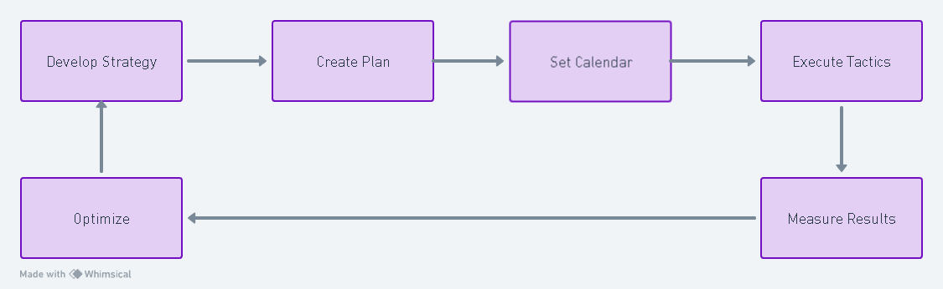

- Develop Strategy
  - Identify core values and unique aspects of [MY LODGE] to highlight in the strategy.
  - Identify who you are trying to reach before choosing what to say or where to say it:
  - Current Members: Keep them informed, involved and proud of the Lodge.
  - The Local Community: Show that the Lodge is active, visible and contributing locally.
  - People Curious About Freemasonry: Help them understand who we are, what we value and what we do without directly soliciting membership.
  - Before creating something, ask: Who is this for, and what do we want them to understand or do next?
- Create Plan
  - Outline actions, like content creation and event participation, with responsible parties and deadlines.
  - Develop a content roadmap for storytelling that aligns with Masonic values and lodge activities.
- Set Calendar
  - Plan at three simple levels:
    - Monthly: Upcoming events, charity work, educational topics, Lodge history, member recognition and recent activities.
    - Quarterly: Review what worked, refresh website/social information, identify community partnerships and plan upcoming seasonal activities.
    - Annually: Map major fundraisers, open houses, Lodge anniversaries, installations, recurring community events and significant Masonic dates.
  - Schedule key dates for content, events and member/community engagement.
  - Whenever possible, create several posts at once and schedule them in advance rather than starting from scratch every time.
  - The 30-day calendar later in this guide is an example and idea bank, not the entire long-term strategy.

- Execute Tactics
  - Implement the planned activities, such as posting on social media, updating the website, and attending community events.
  - Engage members in executing the plan, fostering a sense of ownership and participation.
- Measure Results
  - Track simple results such as post interactions, website activity and attendance at public events.
  - Collect feedback from members and the community to gauge the impact of the activities.
- Optimize
  - Review performance data and feedback to identify what's working and what's not.
  - Adjust the strategy and plan accordingly to improve engagement and reach.
  - Example: If a particular post, message or graphic resonates with your local community use that as a launching point to reuse later.

EXAMPLE MARKETING STRATEGY
Objective: Increase awareness of [MY LODGE], strengthen its connection with [MY CITY], and make it easier for members of the public to understand who we are, what we value and what we do. We will accomplish this through consistent community involvement, public events, educational content and communications that showcase Masonic traditions and values without directly soliciting membership.
Before beginning, establish a simple baseline of where you are today and choose one or two goals to work toward over the next 3–6 months. For example: increase attendance at public events, grow local followers, generate more website visits or receive more questions about the Lodge. You do not need complicated measurements. Know where you started, decide what improvement looks like, and check again later.
Community Engagement:
- Events and Partnerships: Continue participating in local community events and establish partnerships with local organizations (e.g., [OUR CHARITY], [MY CITY Historical Society]).
- Public Open Houses: Regularly host open houses inviting the community to learn about [MY LODGE]'s history, values, and role in [MY CITY].
Content Marketing:
- Educational Content: Create articles, blog posts, and social media content that share the history and core principles of [MY LODGE].
- Testimonials: Share personal stories and testimonials from current members about the positive impact of Freemasonry and [MY LODGE] in their lives.
Social Media:
- Regular Posts: Share weekly social media updates showcasing community involvement, charitable work, and the lodge's unique attributes.
- Historical Highlights: Regularly post historical facts about [MY LODGE]'s contributions to [MY CITY] and its deep-rooted history.
Charity Fundraisers:
- [OUR CHARITY]: Continue the annual fundraising event to support local charitable causes.
Local Press and Media:
- Press Releases: Regularly issue press releases to local magazines, social media pages, and relevant social and media groups, highlighting notable lodge events, charity work, and historical contributions to [MY CITY].
- Community Calendars: Participate in local community calendars to highlight [MY LODGE]'s involvement in the community and share upcoming events and activities.
Masonic Temple Historical Recognition:
- Promote the History: Share the story of [MY LODGE]'s Masonic Temple and how it aligns with the core values of Freemasonry and [MY CITY].
Unity and Brotherhood:
- Highlight the Lodge's Unity: Showcase the strong brotherly bonds between [MY LODGE] members.
- Community Testimonials: Encourage [MY CITY] community members to share their experiences and interactions with [MY LODGE].
Measure Impact:
- Feedback and Analytics: Continuously gather feedback from the community and monitor engagement on social media to assess the effectiveness of the marketing strategy.
- Adjust as Needed: Make adjustments based on feedback and changing community needs while respecting the "no solicitation for membership" rule.

FAQ ABOUT THE 30-DAY EXAMPLE
- How do we promote [OUR CHARITY] in the first 5 days?
  - Share detailed posts and engaging stories about [OUR CHARITY]'s mission and your Lodge's involvement, including images and videos where possible.
- What type of educational content should we post between days 6-10?
  - Create informative posts about Masonic history and the values of Freemasonry, ensuring the content is accessible and interesting to a general audience.
- How do we showcase community involvement from days 11-15?
  - Post highlights and snapshots from local events your Lodge participates in, emphasizing the community impact and your Lodge's role.
- What should our focus be for charity initiatives and social media outreach between days 16-20?
  - Use these days to raise awareness for [OUR CHARITY], engage with local social media groups, and share content that encourages community support and involvement.
- How do we handle engagement and feedback in the last 5 days?
  - Monitor social media engagement, solicit feedback from the community, and use this data to understand the reach and impact of your marketing efforts.

EXAMPLE 30-DAY CONTENT STARTER
This is a starting example, not a requirement to publish every day forever. Choose a schedule your Lodge can realistically maintain. Two or three useful posts each week may be more sustainable than publishing daily simply to fill a calendar. Good content can also be reused with updated wording, images or timing.
- Days 1-5: Community Engagement - Share posts about [OUR CHARITY].
- Days 6-10: Educational Content - Create Masonic history and values posts.
- Days 11-15: Highlight Community Involvement - Showcase [MY LODGE]'s active participation in local events.
- Days 16-20: Promote Charity Initiatives and Social Media Outreach - Raise awareness and support for [OUR CHARITY] while engaging with local social media groups and pages.
- Days 21-25: Event Updates - Share event updates and news with the community through various social media platforms.
- Days 26-30: Engagement and Feedback - Analyze social media engagement and gather community feedback.

FYI’S ABOUT YOUR CONTENT CALENDAR
Use Real Lodge Photos Whenever Possible
- Community service
- Public events
- Lodge activities
- Members doing the work
- Behind-the-scenes preparation
Real photographs show that your Lodge is active and connected to its community.
Use Stock Images When
- You do not have a suitable real photograph.
- You are illustrating a general educational topic.
- You need a background for a graphic.
- The image supports an idea rather than pretending to show your Lodge.
Never use a stock photograph in a way that implies the people shown are members of your Lodge or that the pictured activity actually happened there.
Reuse Good Content
A strong event photo or message can be used more than once if the wording, purpose or timing changes. Avoid repeating the same image so often that your communications begin to look stale.
Batch Your Work
Set aside one planning session each month to gather photos, identify upcoming events, draft several posts, create graphics and schedule content in advance where possible.
Use Repeatable Themes
- Masonic Education
- Community & Charity
- Your Lodge
- Your Members
- Events
- Behind the Scenes

EXAMPLE 30 DAY SOCIAL MEDIA CALENDAR
ONE ACTIVITY CAN CREATE MANY PIECES OF CONTENT
You do not need a completely new idea every time you communicate. One Lodge event can become:
- An announcement
- A reminder
- A Story
- A short video or Reel
- Event-day photographs
- A repost from a community partner
- A thank-you post
- A results or follow-up post
Tagging: Tag organizations, businesses or community partners when they are genuinely involved.
Stories: Use for timely reminders, event setup and behind-the-scenes updates.
Reels / Short Video: Use for quick tours, event preparation, short Masonic facts and activity recaps.
Reposts / Shares: Use when another organization mentions your Lodge or shares something relevant.
Video: It does not need to be professionally produced. A clear smartphone video can be useful and authentic.

DAYS 1 - 5 COMMUNITY ENGAGEMENT
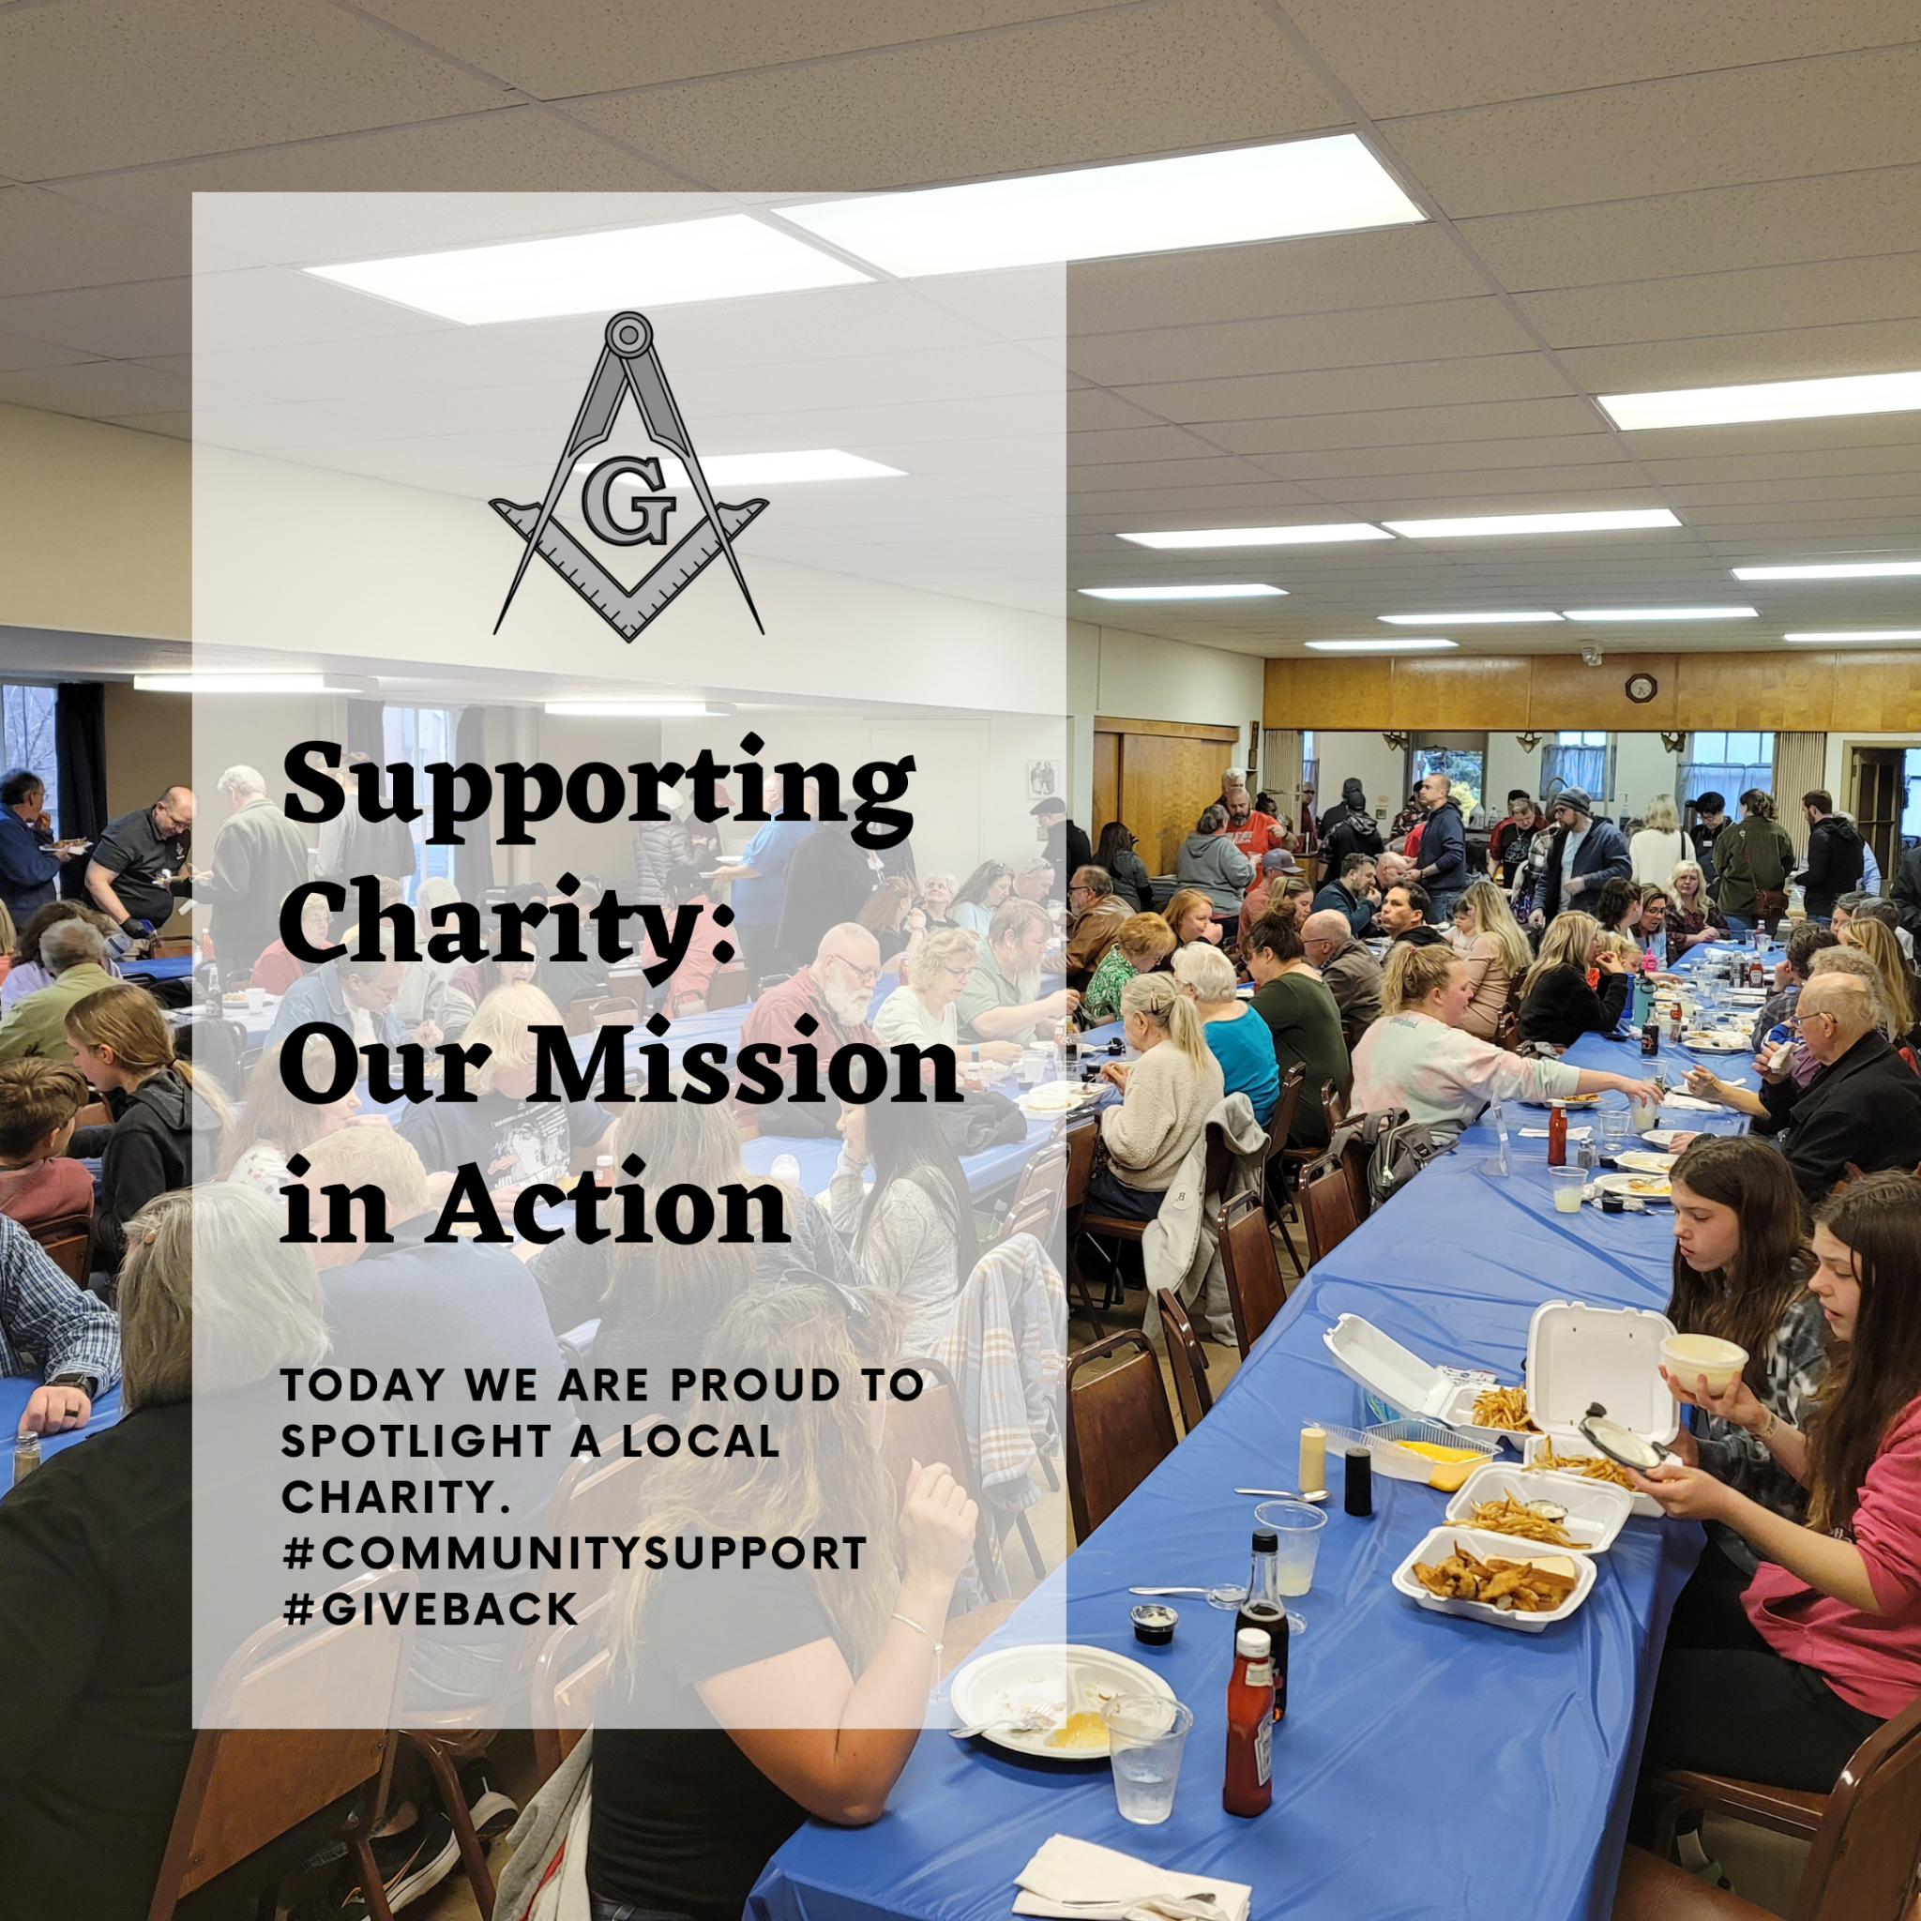
Day 1: 🤝 Supporting our community is at the heart of [MY LODGE]'s mission. Today, we shine the spotlight on [OUR CHARITY], an organization dedicated to [CHARITY MISSION]. Together, we can make a difference. 💙 #CommunityEngagement #SupportLocal
Day 2: 🌟 It's not just about [MY LODGE]—it's about [MY CITY]. Our partnership with [OUR CHARITY] is an essential part of our commitment to [OUR CHARITY]. Learn more about our collaborative efforts. 🤲 #CommunityPartnership #StrongerTogether
Day 3: 💡 Education is the key to understanding the rich traditions of Freemasonry. Explore the core values and history of Masonic principles in our latest blog post. 📚 #MasonicEducation #Freemasonry101
Day 4: 🏛️ Dive into the annals of time with [MY LODGE]. Join us on a journey through Masonic history, uncovering the values that have shaped us into the organization we are today. 📖 #MasonicHistory #Legacy
Day 5: 🧐 Did you know that [MY LODGE] has been a part of [MY CITY]'s history since [CHARTER YEAR]? Discover the fascinating story of our lodge's roots and its role in the local community. 🕰️ #LocalHistory #CommunityPride

DAYS 6 - 10 EDUCATIONAL CONTENT
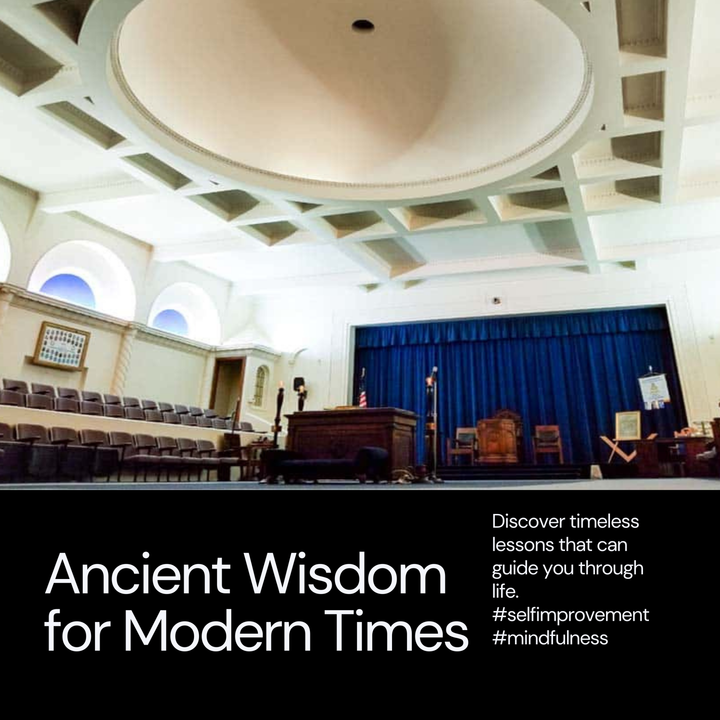
Day 6: 📘 Unlock the secrets of Freemasonry with [MY LODGE]. Our latest article delves into the core Masonic values that guide our journey. Discover the wisdom of generations. 🔍 #MasonicValues #Wisdom
Day 7: 🌄 Every sunrise brings a new opportunity to explore the teachings of Freemasonry. Join us in celebrating the lessons that have shaped our members for generations. 🌅 #MasonicTeachings #LifelongLearning
Day 8: 📜 The Masonic journey is filled with symbolism and significance. Dive into the symbolism of Masonic rituals and uncover their deeper meanings. 💫 #MasonicSymbolism #DeeperUnderstanding
Day 9: 🤝 Brotherhood is one of the cornerstones of Freemasonry. Discover how [MY LODGE] fosters strong bonds of unity among our members and with our community. 💪 #MasonicBrotherhood #Unity
Day 10: 🔍 Uncover the history of Freemasonry's influence on [MY CITY] as we explore significant moments and contributions. Our past has helped shape our vibrant community. 🏛️ #MasonicInfluence #CommunityLegacy

DAYS 11 - 15 HIGHLIGHT COMMUNITY INVOLVEMENT
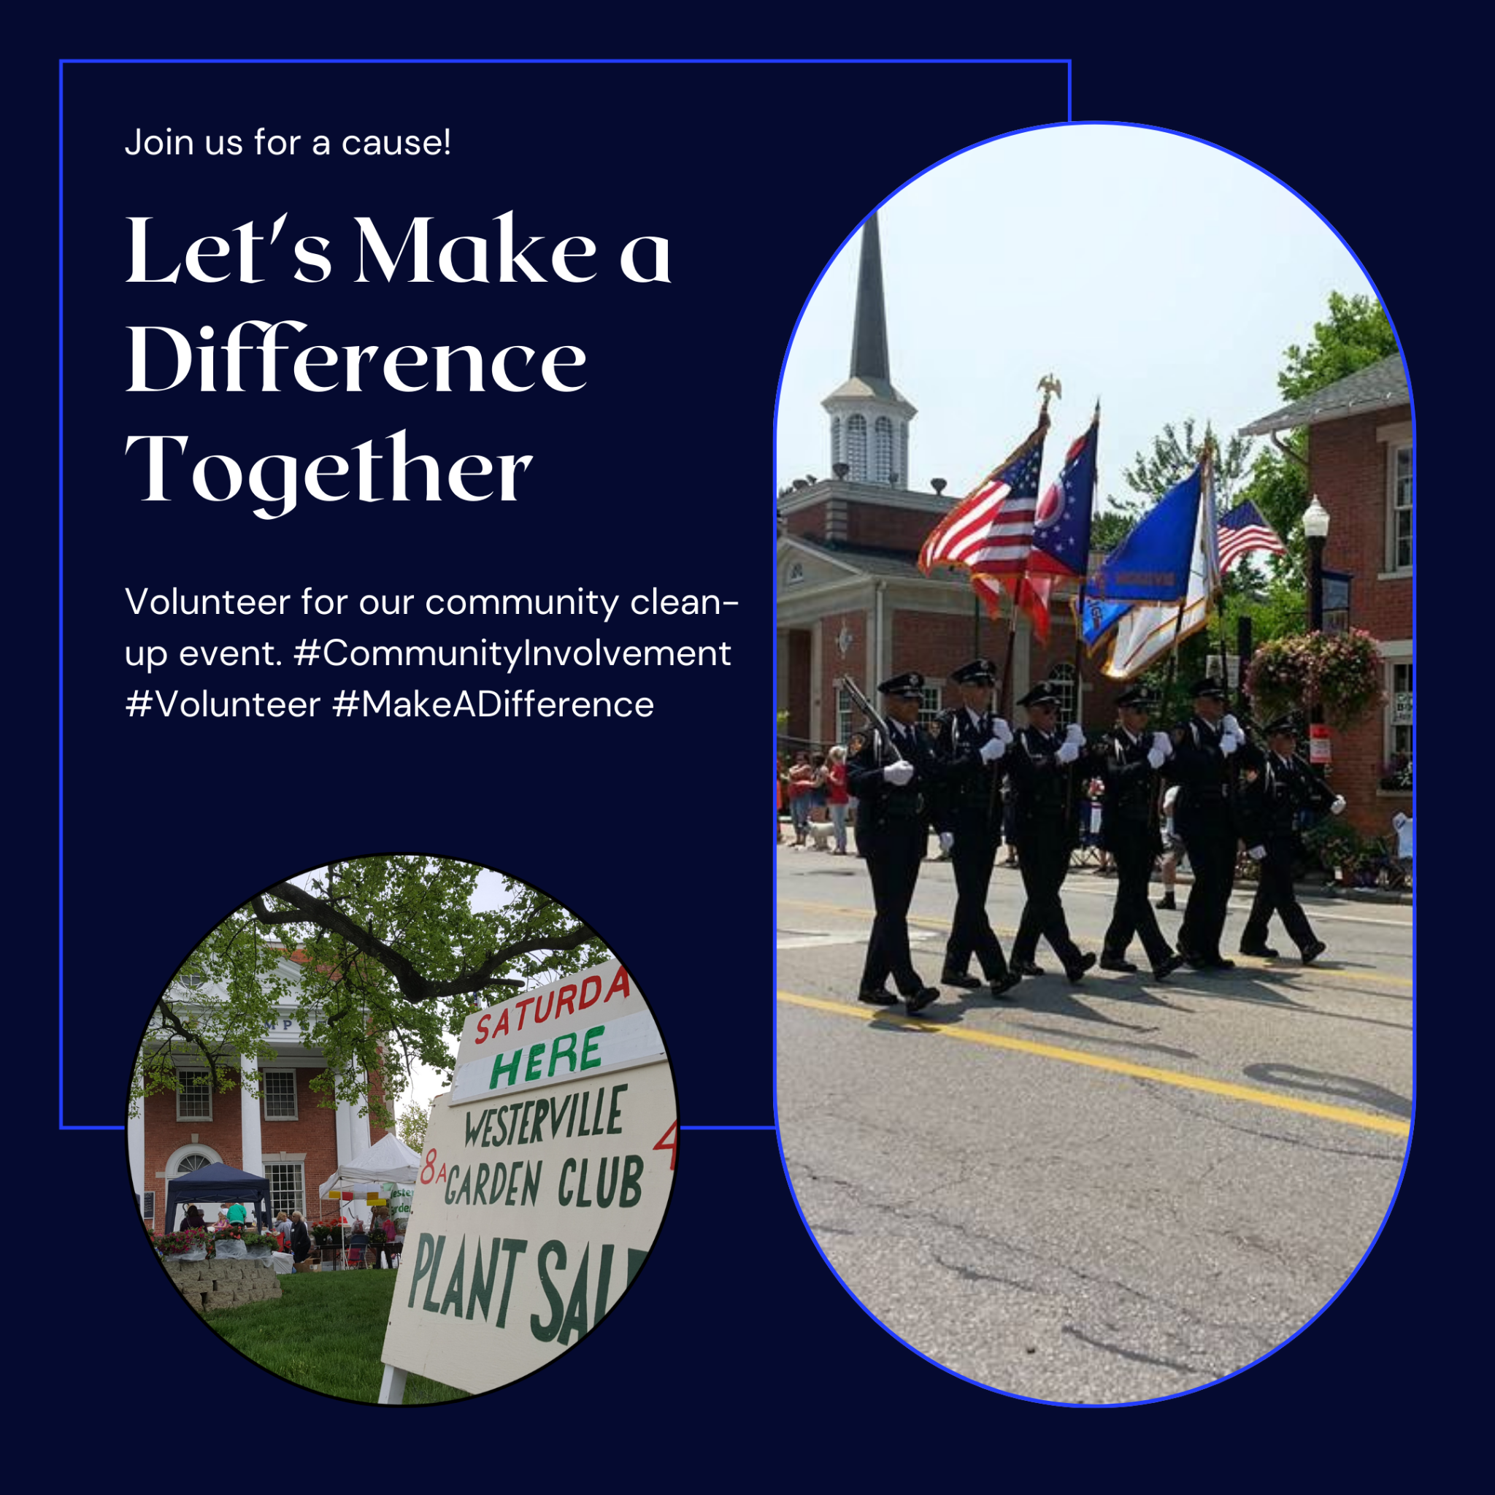
Day 11: 🤲 Our commitment to [OUR CHARITY] is a testament to the strength of our community bonds. Together, we make a positive impact through charitable actions. Join us in supporting our cause. 🌟 #CharityEfforts #CommunityUnity
Day 12: 📅 Mark your calendars! We've got some exciting events on the horizon. Stay tuned for announcements about upcoming gatherings and initiatives. 🗓️ #UpcomingEvents #SaveTheDate
Day 13: 💫 In our lodge, every member has a story. Discover the unique journeys of our members as they share their personal experiences and the difference Freemasonry has made in their lives. 📖 #MasonicStories #LifeChanging
Day 14: 🌱 Like a tree with deep roots, our community grows stronger with time. We're proud of our contributions to [MY CITY] and look forward to many more years of positive impact. 🌿 #CommunityGrowth #DeepRoots
Day 15: 🙌 We're excited to introduce you to some of the faces behind [MY LODGE]. Our members play a vital role in our lodge's success and community involvement. Get to know us better! 👥 #MeetTheMembers #CommunityFaces

DAYS 16 - 20 PROMOTE CHARITY INITIATIVES AND SOCIAL MEDIA OUTREACH
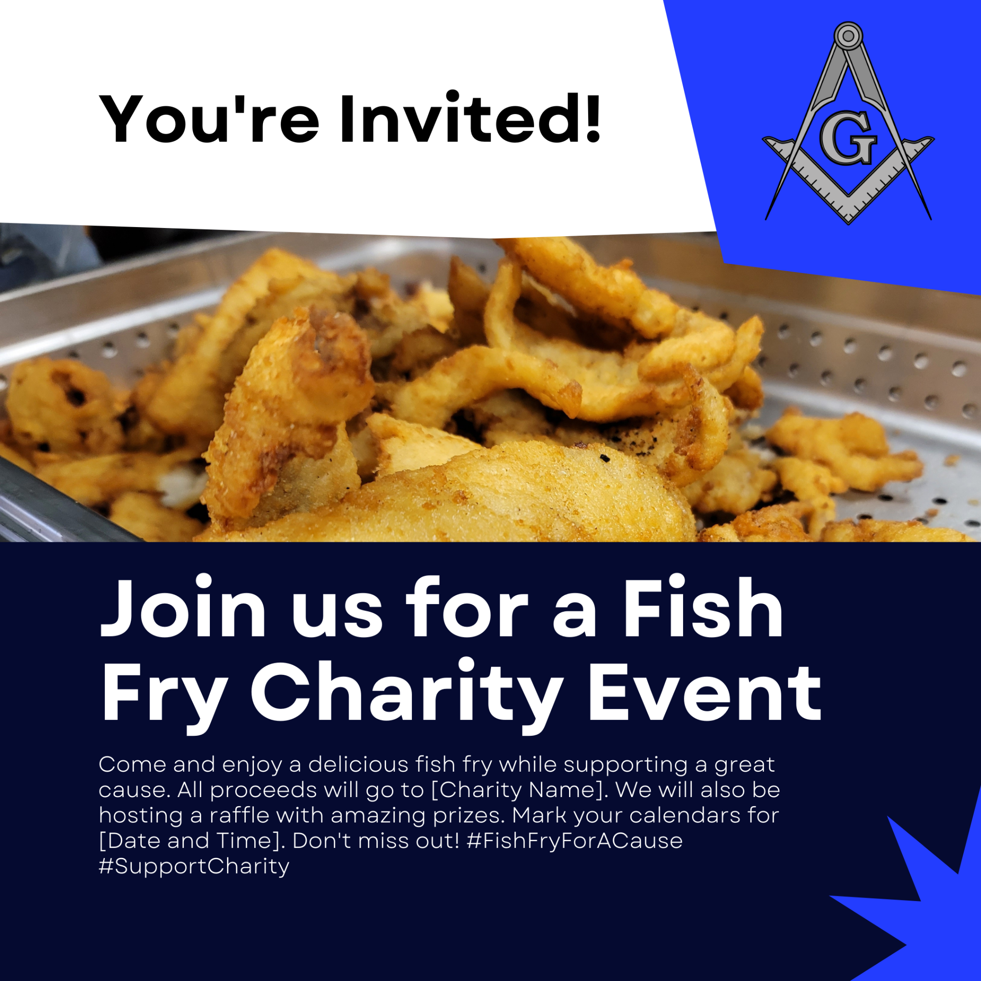
Day 16: 🎉 Get ready for some exciting events coming your way! We're dedicated to making a difference through [OUR CHARITY], and you can be a part of our mission. Stay tuned for more details! 💪 #CharityEvents #GetInvolved
Day 17: 🐟 Join us for a delicious fish fry and support [OUR CHARITY]. Details coming soon! #SupportOurCause #StayTuned 🍟
Day 18: 🌊 [OUR CHARITY] is hosting an event that will leave a lasting impact. Stay tuned for more information on how you can participate. 🌊 #MakeAnImpact #CommunitySupport
Day 19: 🍔 Get ready for some tasty treats and the chance to support [OUR CHARITY]. More details are on the way! 🍗 #TastyTreats #SupportLocal
Day 20: 📢 We're excited to announce an upcoming event that will benefit [OUR CHARITY]. Get ready to make a positive difference. Stay tuned for more information! 🌟 #SupportingACause #StayTuned

DAYS 21 - 25 EVENT UPDATES
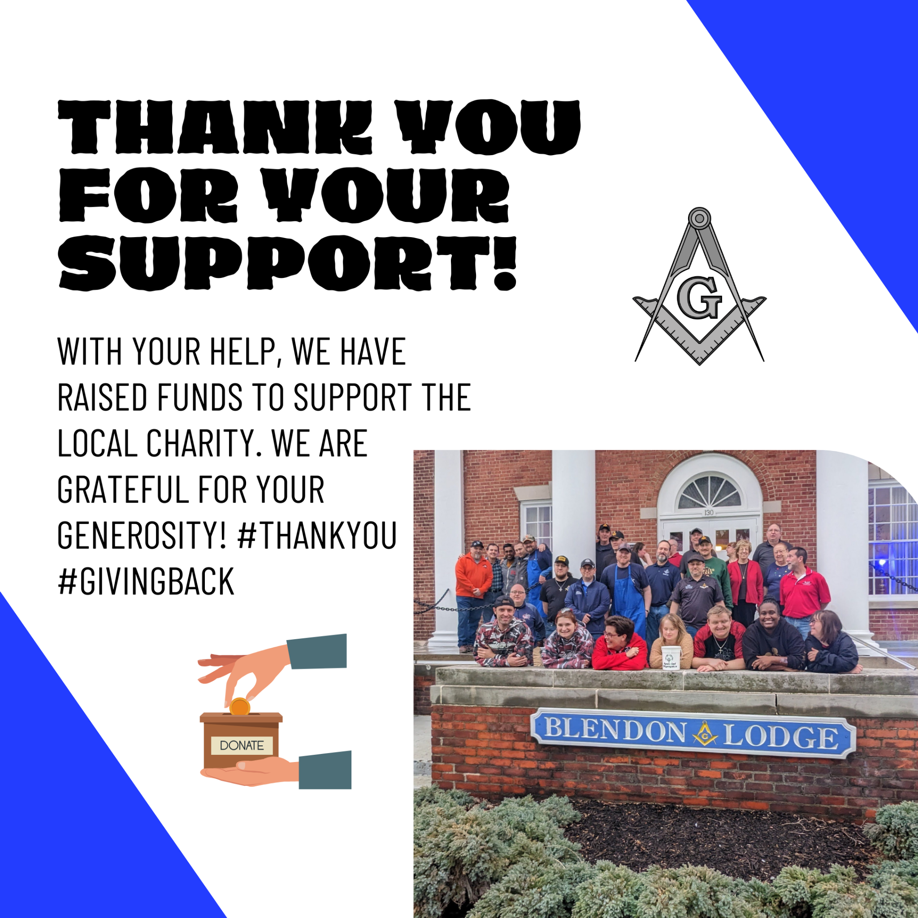
Day 21: 🗞️ Extra! Extra! Read all about it! We're featured in local magazines and social media groups, sharing our commitment to the community and [OUR CHARITY]. Check it out! 📰 #LocalMagazine #CommunityInvolvement
Day 22: 📢 Our story is spreading like wildfire on social media, thanks to your support. Join us in making a difference and keep sharing the love! ❤️ #SocialMediaBuzz #SpreadTheWord
Day 23: 📆 Keep an eye on local community calendars for our upcoming events. We're excited to see you there! 🗓️ #CommunityEvents #GetInvolved
Day 24: 🗞️ Stay updated with our latest news and events by following our social media pages and joining local social and media groups. 📱 #StayConnected #CommunityEngagement
Day 25: 📰 Discover the stories behind [OUR CHARITY] and how we're making an impact in our community. Thank you for your support! We couldn’t have done it without you!. 🌟 #CommunityImpact #ThankYou

DAYS 26 - 30 ENGAGEMENT AND FEEDBACK
In the final stretch, we will gauge the effectiveness of our efforts by actively monitoring engagement on our social media platforms and gathering valuable feedback from our community. Through analytics and feedback, we will assess our reach and impact, allowing us to refine our strategies as needed to continue fulfilling our mission of community engagement, education, and support for [OUR CHARITY]. This five-day period serves as an essential checkpoint, guiding our future endeavors and ensuring our journey towards a stronger, more connected community remains fruitful and meaningful.

EXAMPLE ANALYSIS EXECUTION MAP
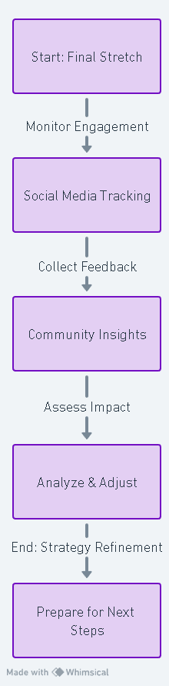
- How do we track engagement on our social media platforms?
  - Look for likes, shares, comments, and new followers. Use built-in platform analytics for insights.
- What kind of feedback should we collect from the community?
  - Seek opinions on event effectiveness, content relevance, and suggestions for improvement.
- How can we assess the reach and impact of our social media efforts?
  - Check the number of people who viewed, reacted to, or interacted with your posts.
- What tools can we use to gather and analyze community feedback?
  - Use simple surveys with tools like Google Forms or SurveyMonkey, and encourage responses with a follow-up post.
- How do we know if we are improving?
  - Compare where you are now to the simple baseline and goals you established earlier.
  - Ask:
    - Are more people attending our public events?
    - Are more local people following or interacting with the Lodge?
    - Are more people visiting our website?
    - Are we receiving more questions or inquiries?
    - Which posts, photos and topics receive the strongest response?
    - Do not worry about tracking everything. Look for patterns over several months and make one or two changes at a time.
    - Example: If real event photos consistently receive more attention than generic graphics, use more real event photography.

EXAMPLE JOURNEY MAPS
HOW SHOULD THE LODGE RESPOND ONLINE?
The Lodge should sound respectful, welcoming and human.
DO
- Answer genuine questions.
- Thank people for compliments and shares.
- Correct factual misunderstandings politely.
- Move sensitive conversations to a private channel when appropriate.
DON’T
- Argue from the Lodge account.
- Use sarcasm or respond emotionally.
- Engage in political fights.
- Publish internal Lodge business intended to remain private.
WHEN SOMETHING GOES WRONG
Not every negative comment is a crisis. A serious issue is something that could materially affect the Lodge’s reputation, member or public safety, operations, community relationships, or legal/Grand Lodge responsibilities.
If that happens:
- Do not react emotionally.
- Gather the facts.
- Notify Lodge leadership.
- Decide who is authorized to respond.
- Pause scheduled promotional posts if they would appear inappropriate.
- Correct misinformation when appropriate.
- Preserve screenshots or records if necessary.
- Follow Grand Lodge policies and legal requirements.
Decide this process before you ever need it.

MEMBERSHIP

Nick discovered [MY LODGE] through a social media post about their charity work. After visiting their website, Nick became captivated by their values and fellowship, he attended an open house, connected with members, and participated in events. His growing involvement led to mentorship and eventually, membership, where he now actively upholds the traditions and community spirit that initially sparked his interest.

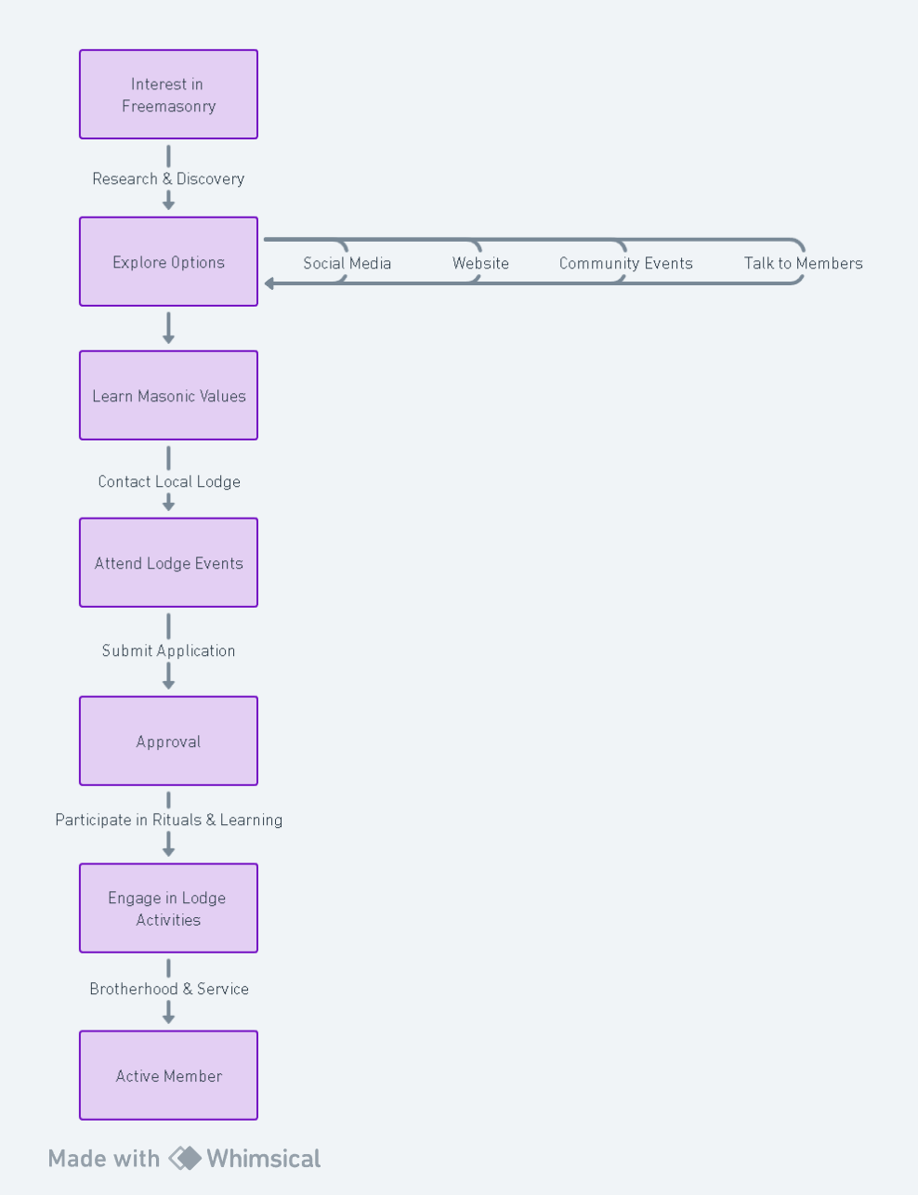

FUNDRAISING EVENT MARKETING
This flowchart shows the full marketing cycle for a fundraising event, from planning before the event to learning from it afterward. The important idea is that event marketing is not a single Facebook post or flyer. It is a connected process: choose your strategy and channels, promote the event in several ways, build local reach, hold the event, then gather feedback and use what you learned to improve the next one. Following the full cycle helps a Lodge stay organized, avoid last-minute promotion, and get better results each time.

